# Call Forwarding

Lineblocs editors allow you to create call flows for basic and advanced call forwarding needs.

This guide will show you how to forward a call to an external phone number using the Lineblocs flow editor.

## Requirements

You will need the following to start forwarding calls using Lineblocs:

1. A DID Number
2. Lineblocs account

## Creating call forward

1. In [Lineblocs dashboard](https://app.lineblocs.com/" \l "/dashboard) click "Create" -> "New Flow"
2. Enter a name for your flow
3. Select the "Call Forward" template
4. Click "Create"

## Edit call forwarding number

To change the number you want to forward to, you are to click the "ForwardBridge" then update the "Number To Call" option.

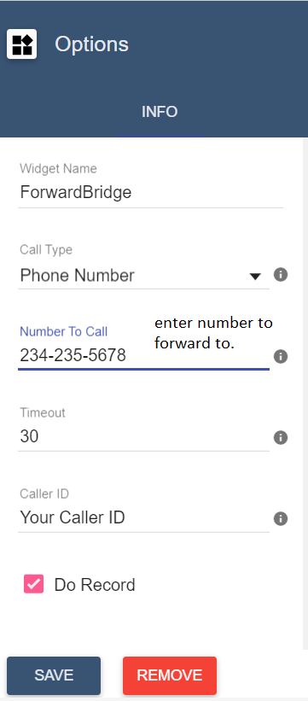

## Change Caller ID

By default, the caller ID will show. If you want to use a custom caller ID instead, you can change the "Caller ID" option.

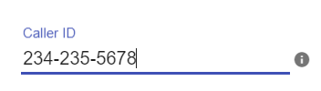

## Record Forwarded Calls

To record your forwarded calls please check the "Do Record" option.

IMG_258

## Using the flow on a DID number

To save all your changes please click IMG_259 in the flow editor.

To use your call flow on a DID Number:

1. In the Lineblocs dashboard, click [DID Numbers -> My Numbers](https://app.lineblocs.com/#/dashboard/dids/my-numbers)
2. Click the "Edit" button next to your number
3. Update the "Attached Flow" field
4. Click "Save"

## Testing the flow

Your calls should now be forwarded to the number you specified along with the Caller ID you set.

## Next Steps

In this guide, we discussed setting up a simple call forward. for more advanced configurations, please see the guides below:

[Simple IVR](https://lineblocs.com/resources/quickstarts/basic-ivr)

[Setup Extension](https://lineblocs.com/resources/quickstarts/setup-extension)